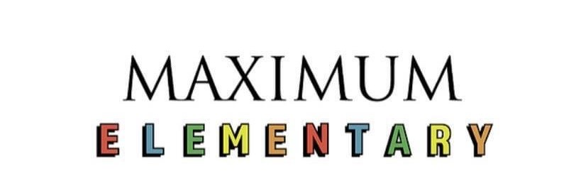

2021-2022 Parent Handbook

Table of Contents

Parent Initial Form 3
Welcome 4
Contact Information 5
Statement of Faith and Purpose 6
Curriculum 7
Tuition and Fees 8-9
Attendance and Calendar 9-10
Uniforms 11
Chapel 11
Inclement Weather 12
Illness 12
Parent Communication 12
Materials Needed 13
After School Information 14
Code of conduct 15

Please read the contents of this handbook in its entirety. Once you have read each section, please initial below for each section. Return the following pages to school with your child to be placed in their file: 3 & 15.
By initialing below, I acknowledge that my student(s) will be required to follow the policies and procedures that lie within. Should policies and procedures be violated, I understand that there may be corrective actions taken, and that there may be additional fees charged for violation of some of the policies.

Policy: Parent Initials:

Introduction _____
Contact Information _____
Statement of Faith and Purpose _____
Curriculum _____
Tuition and Fees _____
Attendance and Calendar _____
Uniforms _____
Chapel _____
Inclement Weather _____
Illness _____
Parent Communication _____
Materials Needed _____
After School Information _____
Code of conduct _____

Welcome
Thank you for choosing Maximum Elementary at LifeSpring to educate your child! We are thrilled that you have chosen us to partner with as we foster your child’s young mind. We hope you and your child will experience a fun and engaging year, full of learning about academics, the Bible, and the world around us! This handbook is designed to give you the basic information that you will need to understand who we are, what we have to offer, and the expectations that we uphold to have a wonderful working relationship with your child and family when it comes to education.
We are a private Christian school whose focus is to train your child to think about the world and academics through a Bible based lens. Our aim is to make learning fun and engaging through a variety of activities and “brain breaks.” Our small class sizes allow us to develop a meaningful relationship with each child, and to spend one on one time as needed with your child. We aim to promote academic success, as well as spiritual, emotional, and psychological success.
Our curriculum is Christian in nature and is published by A.C.E ministries. Your child will be encouraged to think about the Bible and God in all activities throughout the day. Your child will learn the adventures and truths within the Bible not only at chapel each morning, but in their science and math lessons, too. They will be encouraged to memorize scripture and songs about the Bible, and even our holiday celebrations will have a Bible based lens to them.
Using the A.C.E ministries curriculum, your child will have a chance to be self-paced in their learning. They will start with a diagnostic test, and then they will be placed on a level in each subject that meets them right where they are. This allows them to catch up or advance in each specific subject- something a traditional learning environment does not offer. Most importantly, using this curriculum will allow your child to learn how to teach themselves basic educational principles. Research has supported that this skill is valuable in long term academic success.
We are thrilled that your family will be joining us for the ‘21-22 school year. Please read this handbook in its entirety, as we ask that you become familiar with the procedures and policies inside. Do not hesitate to reach out with questions or concerns regarding the contents of this handbook.
Contact Information
Our founder, Angela Didway, is a licensed marriage and family therapist, and has over 40 years of experience in the field of childhood education. She homeschooled her own children with a similar curriculum, and is passionate about helping shape young minds into future Christian leaders. At its core, Angela designed Maximum Elementary at LifeSpring to bring education and Biblical learning together and to spark young hearts with a joy for learning in a way that traditional learning environments cannot provide.
To contact Angela, you may email her at angela@maximumchild.com.

Our lead supervisor and upper elementary school teacher, Meg Perry, has over five years of experience leading and teaching children in a Christian environment. She is the children’s ministry director at LifeSpring Church, and has experience writing and implementing her own Bible based curriculum in that capacity. She has a Bachelor’s degree in Psychology, and is passionate about the emotional and social well being of children. Additionally, she has worked for the Department of Social Services, and is involved in several community organizations to promote the well-being of children as a result.
Meg will be the main point of contact regarding any questions or concerns you may have throughout the year.
To contact Meg, you may email her at meg@maxiumumelementary.com or 864-641-5704.

Our kindergarten teacher, Alicia Poole, has over three years working with children in early childhood education and elementary education environments. She has a Bachelor’s degree in Psychology, and is passionate about teaching and leading children. She has experience providing Applied Behavioral Therapy and Behavioral intervention with children and youth.
To contact Alicia, you may email her at alicia@maximumelementary.com or 864-921-6393.

Statement of Faith and Purpose
As a ministry of LifeSpring Church, Maximum Elementary’s aim is to reach families for Christ, who then reach other families for Christ. At Maximum Elementary, we want to reach families by providing an excellent and God-honoring educational system that promotes the standards and qualifications by which we are called to live. In step with that, we believe that the best way to teach is in line with God’s holy and inspired word, the Bible. We believe that any environment can be a discipling interaction, and we vow to engrain the Word of God into the students’ hearts and minds.
Consistent with LifeSpring Church’s statement of faith, we believe:
JESUS CHRIST
Jesus Christ is at the center of everything. We believe that Jesus is the only one who can reconcile us to God. He lived a sinless and exemplary life, died on the cross in our place, and rose again to prove His victory and empower us for life. We believe that Jesus Christ is coming back again as He promised.

THE TRINITY
We believe in one eternal God who is the Creator of all things. He exists in three Persons: God the Father, God the Son and God the Holy Spirit. He is totally loving and completely holy.

THE BIBLE
We believe that the Bible is God’s Word. It is accurate, authoritative, and applicable to our everyday lives.

THE SEPARATION
We believe that sin has separated each of us from God and His purpose for our lives.

THE RECONCILIATION
We believe that in order to receive forgiveness and a fresh start with God, we must repent of our sins, believe in Jesus, and commit to His will for our lives.

THE CHURCH
We believe in the power and significance of the Church and the necessity of believers to meet regularly together.

Curriculum
At Maximum Elementary, we implement the PACE curriculum, published by A.C.E ministries. Please read below for more information on the PACE curriculum, taken directly from aceministries.com:
“A.C.E. School of Tomorrow® has taken the conventional style textbook and divided it into bite-sized, achievable worktexts called PACEs. Each PACE is similar to a unit in a textbook. Each level consists of 12 PACEs in each subject. PACEs integrate Godly character-building lessons into the academic content, and self-instructional activities are carefully designed to develop thinking skills and create mastery learning.
A.C.E. stands out from other curriculum providers with its individualized, self-instructional, mastery-based approach. With minimal assistance, PACEs allow students to absorb subject material according to their own learning ability rather than being pushed forward or held back by their age. For instance, a student placed in the fifth grade by a conventional school may be taking PACEs in Level 4 math, Level 5 science, and Level 5 English in the A.C.E. program. Students may move ahead in some subject areas and proceed at a slower pace in others.”*
This curriculum will be used in a process at Maximum Elementary. First, your child will take a diagnostic screening online to assess which paces they should start with at the beginning of the year. The diagnostic test will assess their proficiency in science, math, reading comprehension, social studies, Bible knowledge, and spelling. Then, they will start each PACE on their individual levels. Please see the information below for how progress is monitored:
”Each PACE contains several Checkups, which are quizzes covering a section of the PACE. If mastery in an area is not achieved, the Checkup will reveal that weak area. Students can then take the time necessary to review and learn those concepts before proceeding to the next section.
Upon completion of the activities and Checkups, students prepare to take the Self-Test. Here students evaluate themselves, and a supervisor/tutor determines readiness for the final PACE Test. When the Self-Test is successfully completed, the student turns in the PACE and takes the PACE Test the next school morning. The PACE Test objectively measures student mastery of the material.”*

At the end of the year, final testing will be given (similar to traditional learning environments). These tests will display progress and goals met throughout the year. The results will go into each child’s folder, and can be used as records, just like any other learning facility.

Tuition and Fees

 | First Day of School August 16, 2021
 | Last Day of School May 27, 2022
 |  | Weekly payments | two payments  by Aug 10, ‘21 & January 10, 2022 | one payment by Aug 10
Basic Curriculum for 1 year | (12 PACES in 5 subjects) | $ 450.00 | $ 380.00 | $ 350.00
Basic Tuition for 1 year | (38 weeks of instruction) | $ 4,370.00 | $ 3,640.00 | $ 3,582.00
Fall Registration Fee | (includes 1 shirt) | $ 100.00 | $ 100.00 | $ -
4 additional shirts |  | $ 57.00 | $ 57.00 | $ 45.00
end of grade testing fee |  | $ 50.00 | $ 50.00 | $ -
TOTAL ANNUAL COST PER STUDENT |  | $ 5,027.00 | $ 4,227.00 | $ 3,977.00
 |  |  | ($800 savings) | ($1,050 savings)
Your payment includes daily lunch, weekly tumblebus and afterschool pick up by 3:00pm.
Daily pickup after 3:00 | $25 additional per week
Tuition Policies
1. All monies paid are NON-REFUNDABLE
a. unforseen circumstances such as job transfers, terminal illness, & job loss will be taken on a case-by-case basis.
2. All payments are set up for Electronic Funds Transfer (EFT) and will be scheduled according to your instruction.
3. Regardless of plan and start date: All tuition, fees and curriculum are to be paid in full by Friday April 15, 2022.
4. The weekly plan charges $115 per week for 38 weeks of instruction, curriculum, fees & 5 shirts per the chart above.
a. The weekly payment plan is calculated on a 35-week schedule.
b. Drafts will be made from your account over the 2 weeks of Christmas break.
b. A $20 late fee will be charged if a weekly EFT is declined.
5. The two-payment plan is available to those who can pay $2,115 at time of enrollment.
a. An EFT of $2,112 will be set up to draft on January 10, 2022.
b. A $50 late fee will be charged to your account if your check or EFT is declined.
6. The one-payment plan is available to those who can pay $3,977 at the time of enrollment, at the latest by Aug 10.
a. A $100 late fee will be charged to your account if your check or EFT is declined.
7. A full year of tuition, fees and curriculum will be charged for any student starting on or before Monday, Dec 6th.
a. Prorated charges will be calculated from the full tuition column for students who enroll after December 6, 2021
b. A $500 discount will be the maximum savings for one- time payments negotiated after December 6, 2021
8. Sibling Discounts:
b. 10% will be applied to the total family tuition cost across the board on any plan.
c. There is no "mark up," therefore no sibling discount, on our curriculum, shirts or testing,
Contacts:
Angela Didway/admin | 864-612-0409 | initial set up of your payment plan of choice.
Hope Didway/bookkeeper | 864-804-4914 | ongoing questions, comments, concerns regarding your account
Special Notes:
You are welcome to send your child with a breakfast, which they will be allowed to eat upon arrival.
Please send a snack for 3:30 snack time if your child will be staying past 2:30 school pick up time.

Schedule and Calendar
- Each day, the school will open at 7:15am for drop off. The school day starts at 8:00 am, but tardies are not counted until 8:10am.
- The school year must consist of 180 days, as our calendar outlines.
- Pick-up is promptly at 2:30 unless your child is enrolled in our after-school program. If your child is still in the building at 3pm, you will be charged an additional $25, which is our weekly fee for aftercare.
- If your child is out of school for any reason and advance notice is given, they may take home their PACE work material. Should they bring back the given work completed on the schedule requested, they will not be marked absent for the days missed. However, if the work is not able to be done on the timetable given, they will be counted absent.
- Each school year, your child is given 10 unexcused parent absences. If more than 10 absences are used, they must be doctor written excuses.
- Each school day will consist of a schedule like this template:
  - 8:00-8:45- chapel time
  - 8:45-11:00- PACE work (breaks taken as needed)
  - 11:00-11:30- organized recess/lunch set up
  - 11:30-12:30- lunch time/indoor play time
  - 12:30-1:30- elective curriculum/extra PACE time if AM session is not completed
    - Monday- music
    - Tuesday- fitness and health
    - Wednesday- Art
    - Thursday- Computer/technology skills (typing, Microsoft knowledge)
    - Friday- cooking and homemaking skills (following recipes, managing money, keeping a clean home, etc.)
  - 1:30-2:30- read aloud time and silent reading time
- During the spring semester, one of the elective curriculum days will switch to our designated research project days, where students can make progress on their individual projects.
Please see the next page for the yearly calendar, which outlines all our anticipated school closures. You may also check our Facebook page for a digital copy, found at Maximum Elementary at LifeSpring.
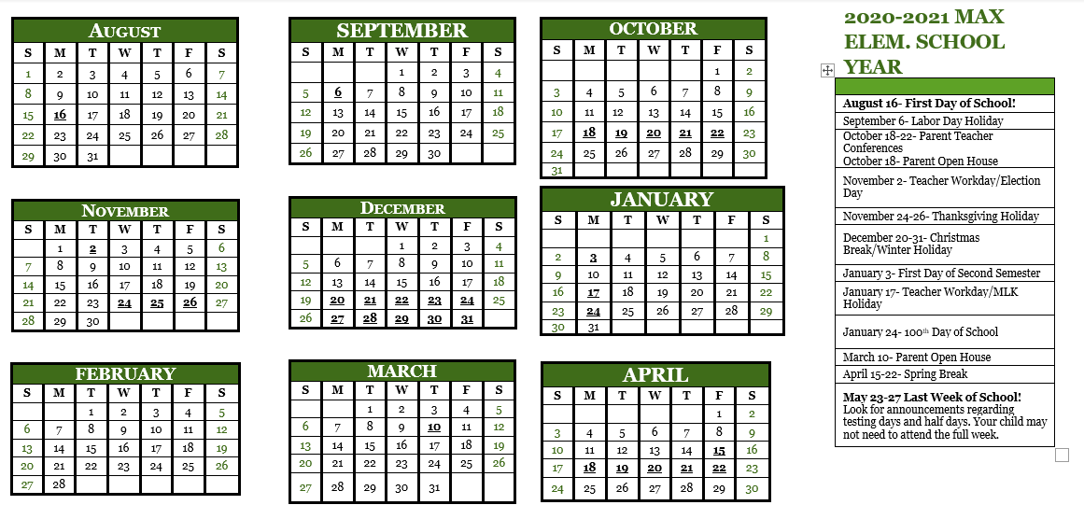
MAY
S | M | T | W | T | F | S
1 | 2 | 3 | 4 | 5 | 6 | 7
8 | 9 | 10 | 11 | 12 | 13 | 14
15 | 16 | 17 | 18 | 19 | 20 | 21
22 | 23 | 24 | 25 | 26 | 27 | 28
29 | 30 | 31
August 16- First Day of School!
September 6- Labor Day Holiday
October 18-22- Parent Teacher Conferences
October 18- Parent Open House
November 2- Teacher Workday/Election Day
November 24-26- Thanksgiving Holiday
December 20-31- Christmas Break/Winter Holiday
January 3- First Day of Second Semester
January 17- Teacher Workday/MLK Holiday
January 24- 100th Day of School
March 10- Parent Open House
April 15-22- Spring Break
May 23-27 Last Week of School!
Look for announcements regarding testing days and half days. Your child may not need to attend the full week.

Uniforms
Each day, your child will be required to wear a Maximum Elementary uniform. Boys may wear shorts or pants, and girl may wear shorts, pants, skorts, or rompers. The uniform consists of black, blue, or khaki bottoms and a Maximum Elementary polo shirt or t-shirt. Please ensure that your child is coming in appropriate footwear that they can play in, as recess is outside each day, weather permitting. The cost of tuition covers five uniform shirts. Pants and shorts are available for purchase, as are extra uniform shirts.
Our uniforms are available for purchase any time. Please see below for pricing information:
Extra shirts- 1 for $25, 4 for $57
Uniform pants, shorts, and skorts- $7 (sizes and styles range)
Rompers: $10

Chapel
Each day, your child will attend a chapel program in the morning. This program will consist of songs, Bible memorization, a small devotion, and an American history based civics lesson. Your child will be engaged in a way that encourages them to grow deeper in their faith. During the year, they will memorize over twenty Bible verses, and will be able to learn theological truths that are important to the Christian walk. This chapel program is often the highlight of the day for our students, as the Bible is brought to life on a developmentally appropriate level.
“Chapel was my favorite part of the day because I loved being able to pray for my family and friends to have a good day while I was at school.”- Grace A.
“I loved to learn about the Bible and all of the battle stories in the Old Testament.”- Dawson C.

Inclement Weather
During the fall and winter months, we may face inclement weather that prevents students and parents from traveling to and from safely. In the case of inclement weather, our closures and/or late openings will be communicated via our parent app, Bright Wheel. You can also find any expected closures or delays on the Facebook page, Maximum Child at LifeSpring.
During these closures, if advance notice is given, your child may be given PACES to take home. In this event, further instruction as to your child’s assignment will be given via the app or phone message home. These closures when anticipated will service similar to the virtual days that many public schools face. If an inclement weather day is not anticipated but occurs, your child may need to attend the given makeup days that are built into the end of year schedule in May. Should this occur, required days will be communicated.
Illness
Should your child be sick during the 21-22 school year, they are able take their PACE work books home and work should you choose to do so. As the attendance policy outlines, if they are to miss being in the building but can still complete the amount of PACE material that would be given to them during a given school day, it will not count against their attendance. However, if your child is not able to complete the work at home on a sick day, they will need to use an unexcused absence or present a doctor’s note on their next day back at school.
We value the health and safety of our students and staff members. For that reason, we ask that you make your child’s health and well-being a top priority in your home. Please do not bring them to school when they are sick, as assignments can be completed elsewhere.
Additionally, we value your child’s psychological well-being. We understand that life happens, and that children can experience stress and anxious moments just like adults. Please feel free to let us know how we can better serve your child when it comes to their mental health.
Parent Communication
At Maximum Elementary, we believe that parent communication is the most important tool we can use to make the most out of learning. Research supports that when parents are involved in their child’s education, learning flourishes. Therefore, we promise to communicate not only how your child is doing in their academics, but what they are learning and how to encourage them and continue their education at home.
For parent communication, we will be using an app called BrightWheel, which can be found in the App store or Google Play store. You can also create an account via webpage at Brightwheel.com. You will receive an email with instructions on how to create your account before the first day of school. There, you can find pictures of your child throughout the day, notes on their experiences throughout the day, and reminders about the upcoming events and meetings throughout the school year.
We also encourage you to like our Facebook page, Maximum Elementary at LifeSpring. We will communicate most messages on this platform as well.
This Photo by Unknown Author is licensed under CC BY-SA-NC

Upper Elementary Supply List

Pencil pouch or box
24 pack crayons
Dry erase markers (1 pack)
File folders (2)
2 pocket folder (1)
Glue sticks
Scissors
Pencils
Individual pencil sharpener
Erasers
Three ring binder (1 inch)
Blank notebook or journal (1)
Page protectors (1)
Water Bottle (reusable)
Storage cube or plastic storage bin (1)

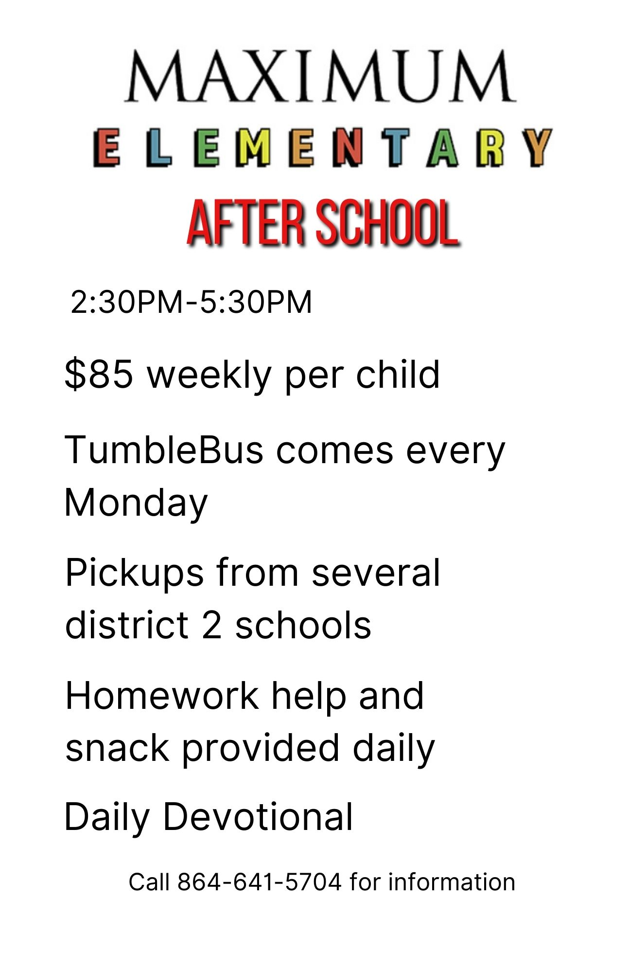
Code of Conduct
By signing the following document, I acknowledge and understand the following policies of Maximum Elementary and the standards that are expected and upheld for my child’s behavior. Should these policies be violated, I understand that appropriate conversations and punishments will occur.
- No cheating of any kind will be tolerated on tests or quizzes. Students are expected to take ownership of their learning, which requires honesty and integrity.
- No bullying of any kind will be tolerated between students. At Maximum Elementary, we act as a family. We treat others with kindness and respect, living out the example of Jesus Christ when it comes to interactions with others.
- Students will abstain from any unclean or unkind speech. We aim for students to be a living example of 1st Timothy 4:12: “Don’t let anyone look down on you because you are young, but set an example for the believers- in speech, in life, in love, in faith and in purity.” Therefore, we will not tolerate cussing, taking the Lord’s name in vain, gossip, or any other hate speech at Maximum Elementary.
- Students are to respect the property of their peers. Stealing will not be tolerated among students. This also includes Maximum Elementary’s property. Damage to property will result in consequences. Students will be expected to take ownership of the space that they learn in, and will be responsible for keeping a clean and orderly learning environment. This also applies to the lunchtime space.
- Students are to strive to obtain and live out the fruits of the spirit: love, joy, peace, patience, kindness, goodness, faithfulness, gentleness, and self-control. While this is a lifelong process and students will never be perfect, we will encourage students to aim towards living these standards.
- Respect and courtesy will be required from every individual in the building (adults and leadership included). During the school day, students will treat each other and their staff members with respect and courtesy, understanding the act of forgiveness and grace as outlined in Ephesians 4:32: “Be kind to one another, tender hearted and forgiving one another, just as Jesus Christ has forgiven you.”
- Defiance will not be tolerated towards staff members and teachers. Students should strive to obey authority set before them, as outlined in Hebrews 13:17: “Have confidence in your leaders and submit to their authority, because they keep watch over you as those who must give an account. Do this so that their work will be a joy, not a burden, for that would be of no benefit to you.”
- To keep the learning environment distraction free, electronics are not permitted during school hours. This includes cell phones, iPods and iPads, MP3 players, personal video game controllers, tablets, etc.

Parent signature: _______________________________________________

